**SUKKUR IBA UNIVERSITY**



# LAB 03

**Assembly language**

**SUBMITTED BY: Abdul Samad**

# CMS: 023-19-0128

# 

**SUBMITTED TO: Sir Riaz**

1. Write an assembly language program that displays your name 10 times (using a loop).

.MODEL SMALL ;64KB

.STACK 100H ;256

.data

msg1 DB 'Abdul Samad $'

.CODE

MAIN PROC

mov ax, @data

mov ds, ax

MOV AH, 02 ;Code for standard out (display)

MOV CX,10

MY_LABEL:

mov ah, 09

lea dx,msg1

int 21h

mov ah,02

mov dl,13

int 21h

mov dl,10

int 21h

LOOP MY_LABEL

MOV AH,4CH

INT 21H

MAIN ENDP

END MAIN

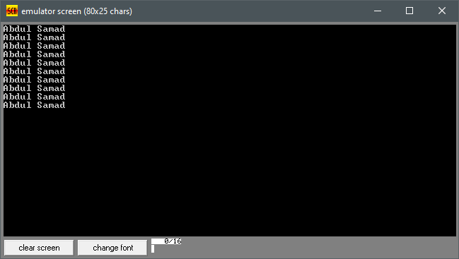

1. Write an assembly language program that displays numbers from 0 to 9, as shown below:

.MODEL SMALL ;64KB

.STACK 100H ;256

.CODE

MAIN PROC

MOV AH, 02 ;Code for standard out (display)

MOV CX,10

MOV BL,48

MY_LABEL:

MOV DL, BL ;Data/character to be displayed

INT 21H ;Interrupt

INC BL ; BL = BL+1

LOOP MY_LABEL

MOV AH,4CH

INT 21H

MAIN ENDP

END MAIN

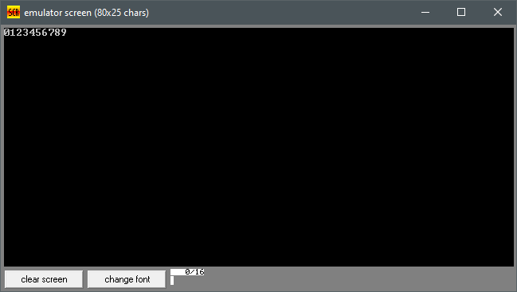

1. Write an assembly language program that asks the user to input a number as an ending range. Then, the program should display numbers from 1 to that ending range (entered by the user), as shown below:

.MODEL SMALL ; 64KB

.STACK 100H ; 256

.DATA

msg DB 'Enter ending range number <1 to 9>: $'

msg1 DB 'The Numbers up to entered range are: $'

.CODE

MAIN PROC

mov ax, @data

mov ds, ax

mov ah, 09h ;

lea dx, msg

int 21h

mov ah, 01h ; Read input from user

int 21h

sub al, 30h

mov cx, ax

mov ah,02

mov dl,13

int 21h

mov dl,10

int 21h

mov ah, 09h

lea dx, msg1

int 21h

mov bl, 01h

loop_start:

mov ah, 02h

mov dl, bl

add dl, 30h

int 21h

mov ah, 02h

mov dl, ' '

int 21h

inc bl

cmp bl, cl

jle loop_start

mov ah, 4ch

int 21h

MAIN ENDP

END MAIN

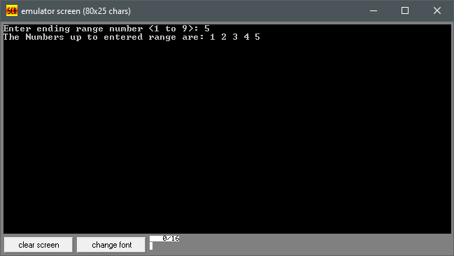

1. Write an assembly language program to display English alphabet (in upper case A - Z) on the screen (using a loop), as shown below:

.MODEL SMALL ;64KB

.STACK 100H ;256

.CODE

MAIN PROC

MOV AH, 02 ;Code for standard out (display)

MOV CX,26

MOV BL,65

MY_LABEL:

MOV DL, BL ;Data/character to be displayed

INT 21H ;Interrupt

INC BL ; BL = BL+1

LOOP MY_LABEL

MOV AH,4CH

INT 21H

MAIN ENDP

END MAIN

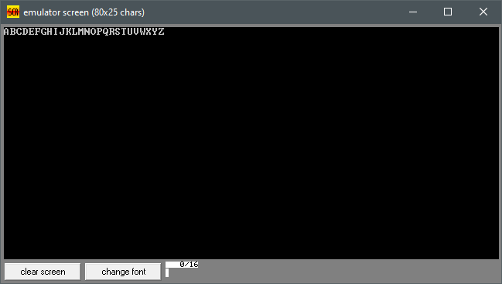

1. Write an assembly language program to display English alphabet (in small cases a - z) on the screen (using a loop), as shown below:

.MODEL SMALL ;64KB

.STACK 100H ;256

.CODE

MAIN PROC

MOV AH, 02 ;Code for standard out (display)

MOV CX,26

MOV BL,97

MY_LABEL:

MOV DL, BL ;Data/character to be displayed

INT 21H ;Interrupt

INC BL ; BL = BL+1

LOOP MY_LABEL

MOV AH,4CH

INT 21H

MAIN ENDP

END MAIN

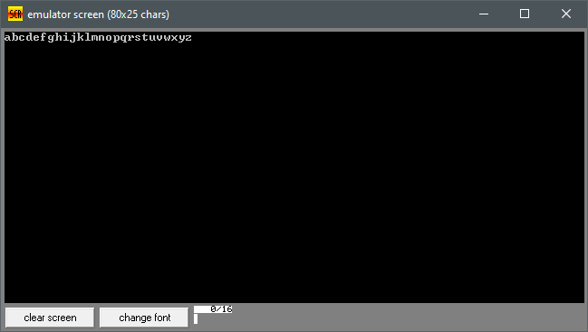

1. Combine the previous two programs to display capital alphabets on one line and small alphabets on the second line, as shown below:
2. 